

**Online Bookstore**

|  |  |  |
| --- | --- | --- |
| **Supervisor:** | *LÊ THANH NHÂN* | |
| **Semester:** | *II* | |
| **Batch No:** | *T1.2206.E1* | |
| **Group No:** | *01* | |
| **Order:** | **Full name** | **Roll No.** |
| *1.* | *Nguyễn Ngọc Bảo Duy* | *Student1387810* |
| *2.* | *Bùi Nguyễn Hải Trí* | *Student1387799* |
| *3.* | *Trịnh Hoàng Phước Sang* | *Student1387804* |
| *4.* | *Lê Mai Minh Thiện* | *Student1387909* |

***Month****: 03* ***Year****: 2023*



This is to certify that

|  |  |
| --- | --- |
| **Mr.** | ***Nguyễn Ngọc Bảo Duy*** |
| **Mr.** | ***Bùi Nguyễn Hải Trí*** |
| **Mr.** | ***Trịnh Hoàng Phước Sang*** |
| **Mr.** | ***Lê Mai Minh Thiện*** |

Have successfully Designed & Developed

|  |  |  |
| --- | --- | --- |
|  |  |  |
| **Online Bookstore** | | |

Submitted by:

|  |
| --- |
| **Mr. LE THANH NHAN** |

Date Of Issue:

|  |  |
| --- | --- |
|  |  |

Authorized Signature:

|  |  |
| --- | --- |
|  |  |
| **Content** | | | |

Content

Acknowledge

Synposis

Review1 01

Review2 07

Review3 28

Testting Document 50

Final Checklist 51

Tasksheet 52

|  |
| --- |
| **Acknowledge** |

As we understand that the Project is a step-by- step learning environment that closely simulates the class-room and Lab based learning environment into actual implementation. It is a projectimplementation at your fingertips!! An electronic, live juncture on the machine that allows you to.

✓ Practice step by step i.e. laddered approach.

✓ Build a larger more robust application.

✓ Usage of certain utilities in applications designed by user.

✓ Single program to unified code leading to a complete application.

✓ Learn implementation of concepts in a phased manner.

✓ Enhance skills and add value.

✓ Work on real life projects.

✓ Give a real life scenario and help to create applications more complicated and useful.

✓ Mentoring through email support.

We would like to send a great thank to our professor, Mr Le Thanh Nhan and others student for the addorable supports during the time in project.

Beside serveral mistakes we had made in the project, we hope to have more oppotunities to widen our knownledge in web developing world.

We also thank you so much for your infomation and the “demo” project from India APTECH to help us get more reality experience in this project. Since we have gained more experience from this project, we will not stop learning any thing as much as we can to be more successful in the future.

Your Sincerely,

Team Group 01.

|  |
| --- |
| **Synposis** |

The Objective of this program we aim is to give a sample project to work on real life projects. These applications help us build a larger more robust application.

The objective is not to teach us front-end or back-end technology but to provide us with a real life scenario and help us create basic applications using the tools.

Hence, we can revise the chapters before we start with the project.

This project is meant for students like us who have completed the module of Semester II, as well as special subjects those are Java and PHP. These programs should be done in the Lab sessions with assistance of the faculty if required.

The website (in this project) is a world that brings everything about the potteries and crockeries into your experience.

It is very essential for us that will have a clear understanding of the subject. We think we should go through the project and solve the assignments as per requirements given.

**Review 01**

|  |
| --- |
| **Problem Definition** |

Papyrus.com offers huge collection of books in diverse category of Fiction, Non-fiction, Biographies, History, Religions, Self -Help, Children. We also sell in vast collection of Investments and Management, Computers, Engineering, Medical, College and School text references books proposed by different institutes as syllabus across the country. Besides to this, we also offer a large collection of E-Books at very fair pricing.

We attempt to extend the customer satisfaction by catering easy user-friendly search engine, quick and user-friendly payment options and quicker delivery systems. Upside to all of this, we are disposed to provide exciting offers and pleasant discounts on our books.

✓ Provide function for member register.

✓ Provide information of the product to customers and members.

✓ Provide shopping cart function so customers and members can order products.

✓ The member can take their Privacy through Member Control Panel (MCP)

✓ Receive comments and ratings from customers and members to improve service quality as well as product quality.

An Admin Control Panel (ACP) that support about management system:

✓ Administrators are able to add, update product information quickly and accurately.

✓ Administrators are able to manage members and their feedback, comment or rating.

✓ Administrators are able to manage delivery progress belong to orders.

✓ Administrators are able to report statistics.

The Role of User and Admin:

|  |
| --- |
| **Customer Requirements Specifications** |

1. User:

✓ Can register as a member and manage personal account.

✓ Can view and buy products.

✓ Can give feedback, comment, rate about products.

✓ Can view their orders.

2. Administrator

✓ Can add / edit / deactivate products and categories.

✓ Can view customer’s information or deactivate an account.

✓ Can reply the feedback or comment.

✓ Can view all orders and approve orders.

✓ Can view report statistics.

**User:**

**input:**

- Member registration data.

- Order’s selected products.

- Feedbacks about products

**Process:**

- Search products from database by categories, by product types.

- Process customer registration information.

- Process product’s feedback.

- Process customer orders.

**Output:**

- Notification of successful registration / failure.

- Product information.

- Notification of successful making order.

**Webmaster:**

**input:**

- Administrator login data.

- Product and category data to add / edit / delete.

- Member data to be search / delete.

- Order data to be search / approve.

**Process:**

- Add / edit / delete products.

- View information of all members.

- Change member account’s status.

- View all orders.

- Update order status.

**Output:**

- Notification to add / edit / delete products success / failure.

- Notification to change member account’s status.

- Notification to update order’s status.

**Hardware / software requirement**

|  |  |  |
| --- | --- | --- |
| **Sr.** | **Item** | **Description** |
| 1. | Operating system | Windows 7, 8, or higher |
| 2. | Hardware | CPU Cores or better with 2 Gigabytes of RAM or better |
| 3. | Web Browser | Version in later of: Edge, Firefox, Chrome, etc… |
| 4. | Fonts | Standard font Unicode: Arial, Tahoma, Lucida Console,  Times New Roman, etc… |
| 5. | Other requirement | NodeJS, Git, XAMPP 7.3 or later | A working internet connection. |

**Review 02**

|  |
| --- |
| **Data Flow Diagram** |

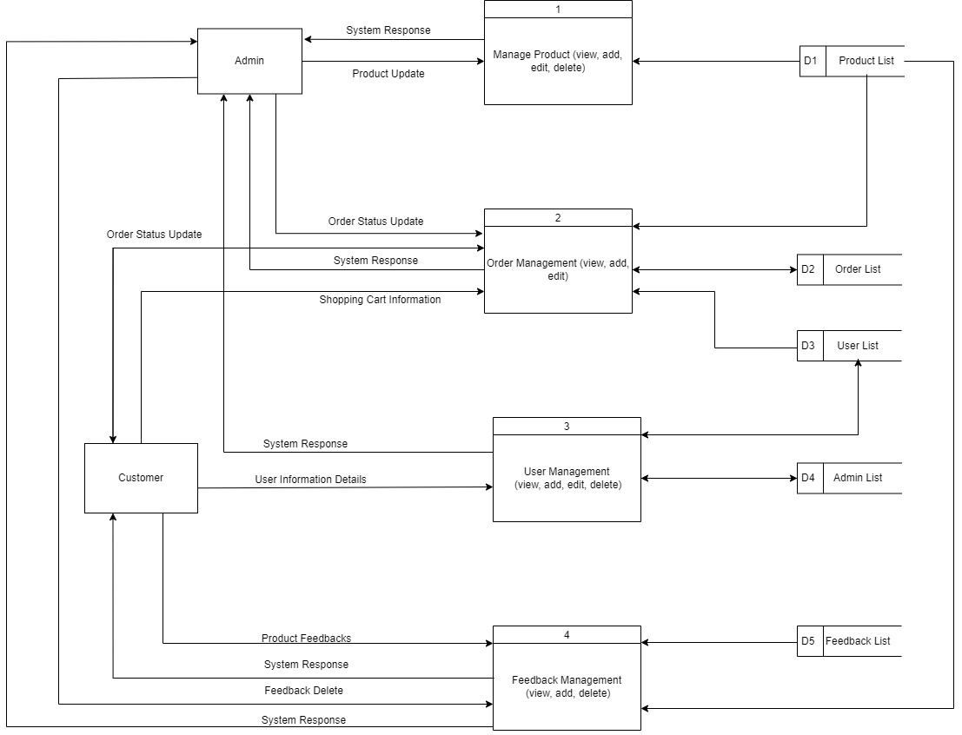

|  |
| --- |
| **A. Entity Relationship Diagram** |

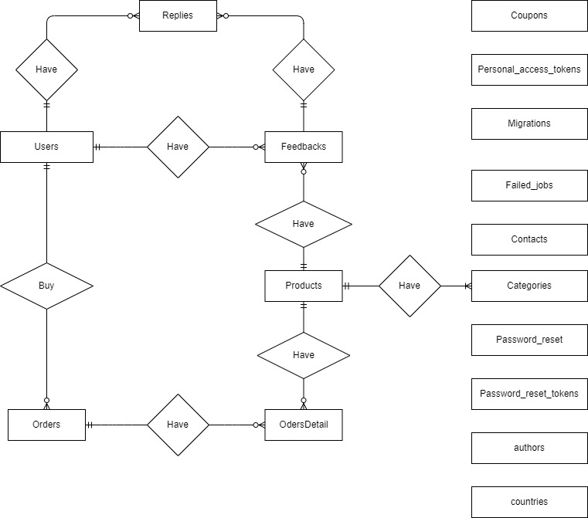

|  |
| --- |
| **B. Entity Attributes** |

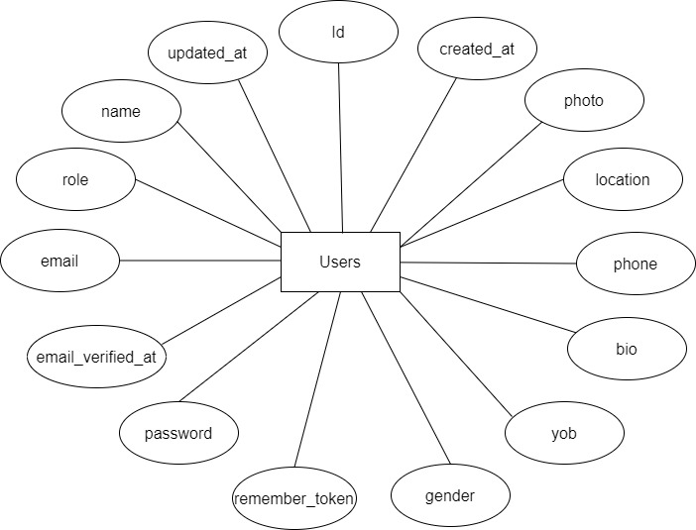

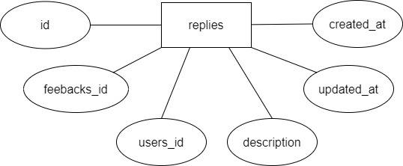

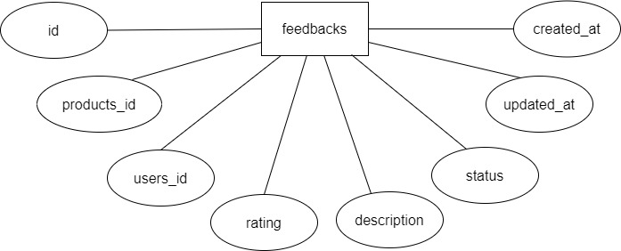

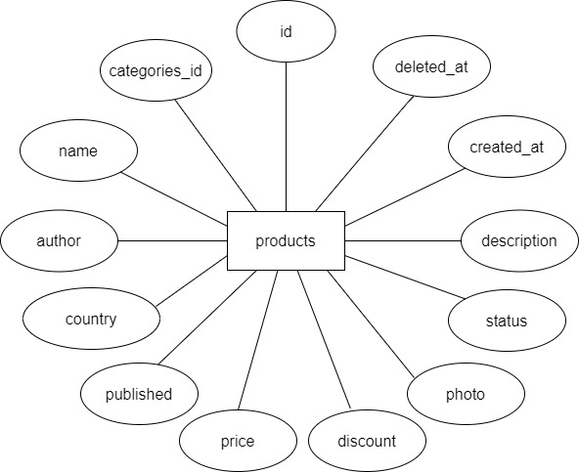

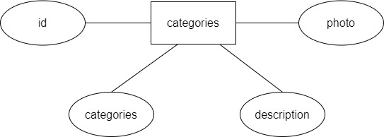

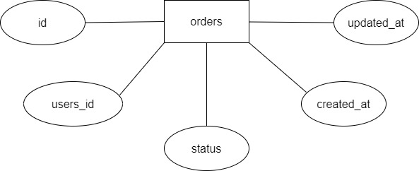

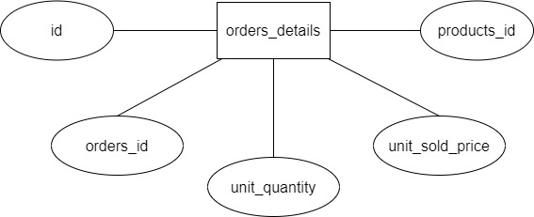

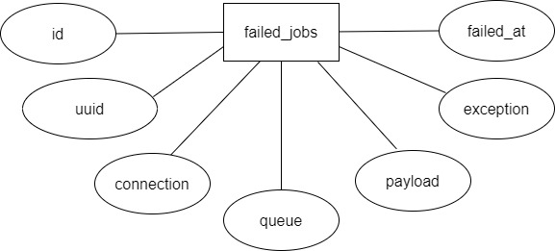

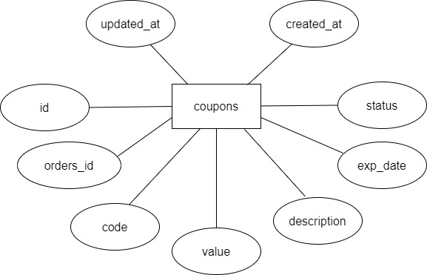

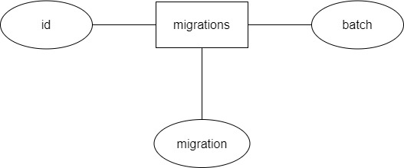

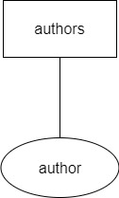

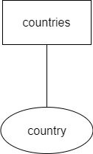

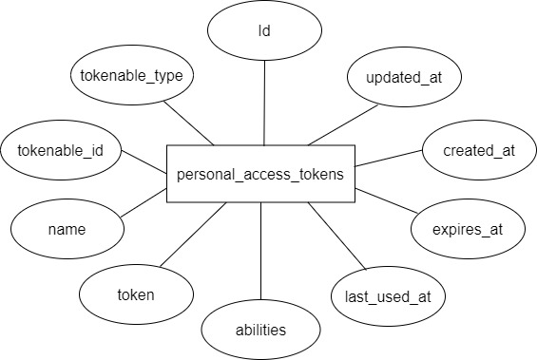

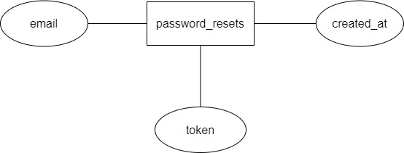

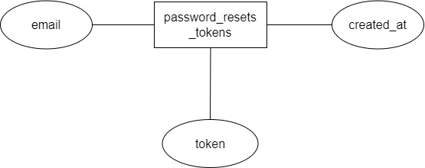

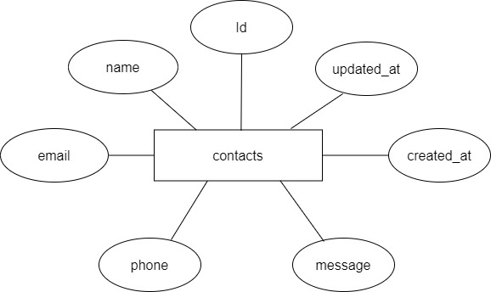

|  |
| --- |
| **A. Table Design** |

|  |  |  |  |  |  |
| --- | --- | --- | --- | --- | --- |
|  |  |  | **products** | |  |
| **Serial** | **Fields** | **Data type** | **Keys** | **Constrains** | **Description** |
| 1 | id | BIGINT(20) | Primary key | Not null | Product identification |
| 2 | categories_id | BIGINT(20) | Foreign key | Not null | Category identification |
| 3 | name | VARCHAR(150) |  | Not null | Product’s name |
| 4 | author | VARCHAR(150) |  | Not null | Books’ author |
| 5 | country | VARCHAR(45) |  | Not null | Books’ country |
| 6 | published | INT(11) |  | Not null | Publish date |
| 7 | price | DECIMAL(4, 2) |  | Not null | Product’s price |
| 8 | discount | DECIMAL(3, 2) |  | Not null | Product’s discount |
| 9 | photo | VARCHAR(150) |  | Not null | Product’s picture |
| 10 | description | TEXT |  | Not null | Product’s description |
| 11 | status | VARCHAR(255) |  | Not null | Product’s status |
| 12 | created_at | TIMESTAMP |  | Not null | Created date |
| 13 | updated_at | TIMESTAMP |  | Null | Deleted date |

|  |  |  |  |  |  |
| --- | --- | --- | --- | --- | --- |
|  |  |  | **categories** | |  |
| **Serial** | **Fields** | **Data type** | **Keys** | **Constrains** | **Description** |
| 1 | id | BIGINT(20) | Primary key | Not null | Category identification |
| 2 | categories | VARCHAR(45) | Foreign key | Not null | Books’ category |
| 3 | description | TEXT |  | Not null | Books’ description |
| 4 | photo | VARCHAR(150) |  | Not null | Books’ picture |

|  |  |  |  |  |  |
| --- | --- | --- | --- | --- | --- |
|  |  |  | **feedbacks** | |  |
| **Serial** | **Fields** | **Data type** | **Keys** | **Constrains** | **Description** |
| 1 | id | BIGINT(20) | Primary key | Not null | Feedback identification |
| 2 | products_id | BIGINT(20) | Foreign key | Not null | Product identification |
| 3 | users_id | VARCHAR(50) | Foreign key | Not null | Customer's identification |
| 4 | rating | INT(11) |  | Not null | Customer’s rating |
| 5 | description | TEXT |  | Null | Feedback's comment |
| 6 | created_at | TIMESTAMP |  | Not null | Feedback’s created date |
| 7 | udated_at | TIMESTAMP |  | Not null | Feedback’s updated date |

|  |  |  |  |  |  |
| --- | --- | --- | --- | --- | --- |
|  |  |  | **replies** | |  |
| **Serial** | **Fields** | **Data type** | **Keys** | **Constrains** | **Description** |
| 1 | id | BIGINT(20) | Primary key | Not null | Reply identification |
| 2 | feedbacks_id | BIGINT(20) | Foreign key | Not null | Feedback identification |
| 3 | users_id | VARCHAR(50) | Foreign key | Not null | Customer's identification |
| 4 | description | TEXT |  | Not null | Feedback's comment |
| 5 | status | VARCHAR(255) |  | Not null | Feedback’s status |
| 6 | created_at | TIMESTAMP |  | Not null | Feedback’s created date |
| 7 | updated_at | TIMESTAMP |  | Not null | Feedback’s updated date |

|  |  |  |  |  |  |
| --- | --- | --- | --- | --- | --- |
|  |  |  | **users** |  |  |
| **Serial** | **Fields** | **Data type** | **Keys** | **Constrains** | **Description** |
| 1 | id | BIGINT(20) | Primary key | Not null | User identification |
| 2 | name | VARCHAR(150) |  | Not null | User name |
| 3 | role | VARCHAR(45) |  | Not null | User’s role |
| 4 | email | VARCHAR(150) |  | Not null | User email |
| 5 | email_verified_at | TIMESTAMP |  | Null | Email verified date |
| 6 | password | VARCHAR(150) |  | Not null | User’s password |
| 7 | remember_token | VARCHAR(100) |  | Null | User’s remember token |
| 8 | gender | VARCHAR(45) |  | Null | User gender |
| 9 | yob | DATE |  | Null | User birthday |
| 10 | phone | VARCHAR(45) |  | Null | User phone number |
| 11 | location | VARCHAR(150) |  | Null | User address |
| 12 | bio | TEXT |  | Null | User’s biography |
| 13 | photo | VARCHAR(150) |  | Null | User’s photo |
| 14 | created_at | TIMESTAMP |  | Not null | Register date |
| 15 | updated_at | TIMESTAMP |  | Not null | Updated date |

|  |  |  |  |  |  |
| --- | --- | --- | --- | --- | --- |
|  |  |  | **orders** |  |  |
| **Serial** | **Fields** | **Data type** | **Keys** | **Constrains** | **Description** |
| 1 | id | BIGINT(20) | Primary key | Not null | Order identification |
| 2 | users_id | BIGINT(20) | Foreign key | Not null | Customer identification |
| 3 | status | VARCHAR(191) |  | Not null | Order's status |
| 4 | created_at | TIMSTAMP |  | Not null | Order's created date |
| 5 | updated_at | TIMESTAMP |  | Not null | Order's updated date |

|  |  |  |  |  |  |
| --- | --- | --- | --- | --- | --- |
|  |  |  | **order_detail** | |  |
| **Serial** | **Fields** | **Data type** | **Keys** | **Constrains** | **Description** |
| 1 | id | BIGINT(20) | Primary key | Not null | Order detail identification |
| 2 | orders_id | BIGINT(20) | Foreign key | Not null | Order identification |
| 3 | products_id | BIGINT(20) | Foreign key | Not null | Product identification |
| 4 | unit_quantity | INT(11) |  | Not null | Product's quantity |
| 5 | Unit_sold_price | DECIMAL(6,2) |  | Not null | Product's price |

|  |  |  |  |  |  |
| --- | --- | --- | --- | --- | --- |
| **personal_access_tokens** | | | | | |
| **Serial** | **Fields** | **Data type** | **Keys** | **Constrains** | **Description** |
| 1 | id | BIGINT(20) | Primary key | Not null | Personal access token id |
| 2 | tokenable_type | VARCHAR(255) |  | Not null | Tokenable type |
| 3 | tokenable_id | BIGINT(20) |  | Not null | Tokenable identification |
| 4 | name | VARCHAR(255) |  | Not null | Personal access token name |
| 5 | token | VARCHAR(64) |  | Not null | Token |
| 6 | abilities | TEXT |  | Null | Personal access token ability |
| 7 | last_used_at | TIMESTAMP |  | Null | Last used date |
| 8 | expires_at | TIMESTAMP |  | Null | Expire date |
| 9 | created_at | TIMESTAMP |  | Null | Created date |
| 10 | udpated_at | TIMESTAMP |  | Null | Updated date |

|  |  |  |  |  |  |
| --- | --- | --- | --- | --- | --- |
| **password_resets** | | | | | |
| **Serial** | **Fields** | **Data type** | **Keys** | **Constrains** | **Description** |
| 1 | email | VARCHAR(255) |  | Not null | Email |
| 2 | token | VARCHAR(255) |  | Not null | Token |
| 3 | created_at | TIMESTAMP |  | Null | Created date |

|  |  |  |  |  |  |
| --- | --- | --- | --- | --- | --- |
| **password_reset_tokens** | | | | | |
| **Serial** | **Fields** | **Data type** | **Keys** | **Constrains** | **Description** |
| 1 | email | Varchar(255) | Primary key | Not null | Email |
| 2 | token | varchar(255) |  | Not null | Token |
| 3 | created_at | Timestamp |  | Null | Created date |

|  |  |  |  |  |  |
| --- | --- | --- | --- | --- | --- |
| **failed_jobs** | | | | | |
| **Serial** | **Fields** | **Data type** | **Keys** | **Constrains** | **Description** |
| 1 | id | BIGINT(20) | Primary key | Not null | Failed job identification |
| 2 | uuid | VARCHAR(255) |  | Not null | Uu identification |
| 3 | connection | TEXT |  | Not null | Connection |
| 4 | queue | TEXT |  | Not null | Queue |
| 5 | payload | LONGTEXT |  | Not null | Payload |
| 6 | exception | LONGTEXT |  | Not null | Exception |
| 7 | failed_at | TIMESTAMP |  | Not null | Faled job date |

|  |  |  |  |  |  |
| --- | --- | --- | --- | --- | --- |
| **migrations** | | | | | |
| **Serial** | **Fields** | **Data type** | **Keys** | **Constrains** | **Description** |
| 1 | id | INT(10) | Primary key | Not null | Migration identification |
| 2 | migration | VARCHAR(255) |  | Not null | Migration |
| 3 | batch | INT(11) |  | Not null | Migration batch |

|  |  |  |  |  |  |
| --- | --- | --- | --- | --- | --- |
| **contact** | | | | | |
| **Serial** | **Fields** | **Data type** | **Keys** | **Constrains** | **Description** |
| 1 | id | BIGINT(20) | Primary key | Not null | Customer’s identification |
| 2 | name | VARCHAR(255) |  | Not null | Customer’s name |
| 3 | email | VARCHAR(255) |  | Not null | Customer’s email |
| 4 | phone | VARCHAR(255) |  | Not null | Customer’s phone |
| 5 | message | TEXT |  | Not null | Customer’s message |
| 6 | created_at | TIMESTAMP |  | Not null | Contact’s created date |
| 7 | updated_at | TIMESTAMP |  | Not null | Contact’s updated date |

|  |  |  |  |  |  |
| --- | --- | --- | --- | --- | --- |
| **authors** | | | | | |
| **Serial** | **Fields** | **Data type** | **Keys** | **Constrains** | **Description** |
| 1 | author | VARCHAR(255) | Primary key | Not null | Author name |

|  |  |  |  |  |  |
| --- | --- | --- | --- | --- | --- |
| **countries** | | | | | |
| **Serial** | **Fields** | **Data type** | **Keys** | **Constrains** | **Description** |
| 1 | country | VARCHAR(255) | Primary key | Not null | Country name |

|  |  |  |  |  |  |
| --- | --- | --- | --- | --- | --- |
| **coupons** | | | | | |
| **Serial** | **Fields** | **Data type** | **Keys** | **Constrains** | **Description** |
| 1 | id | BIGINT(20) | Primary key | Not null | Coupon identification |
| 2 | orders_id | BIGINT(20) |  | null | Order identification |
| 3 | code | VARCHAR(150) |  | Not null | Coupon code |
| 4 | value | DECIMAL(3,2) |  | Not null | Coupon value |
| 5 | description | TEXT |  | Not null | Coupon description |
| 6 | exp_date | DATE |  | Not null | Expire date |
| 7 | status | VARCHAR(45) |  | Not null | Coupon status |
| 8 | created_at | TIMESTAMP |  | Not null | Created date |
| 9 | updated_at | TIMESTAMP |  | Not null | Updated date |

|  |
| --- |
| **B. Relationship Diagram** |

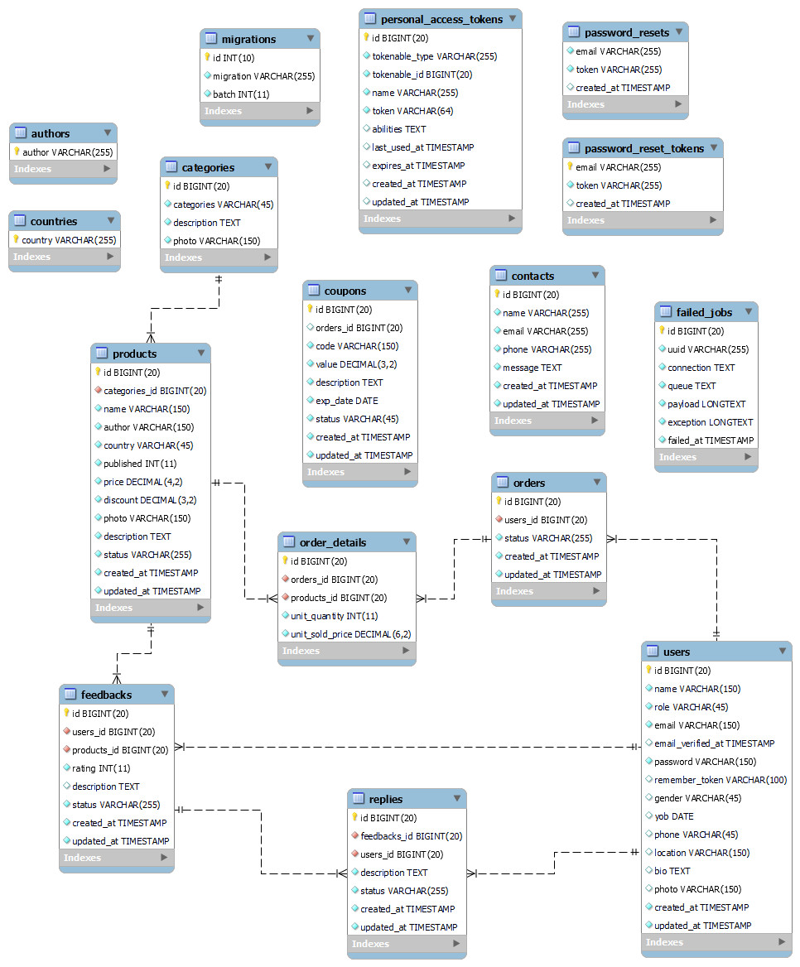

|  |
| --- |
| **SiteMap** |

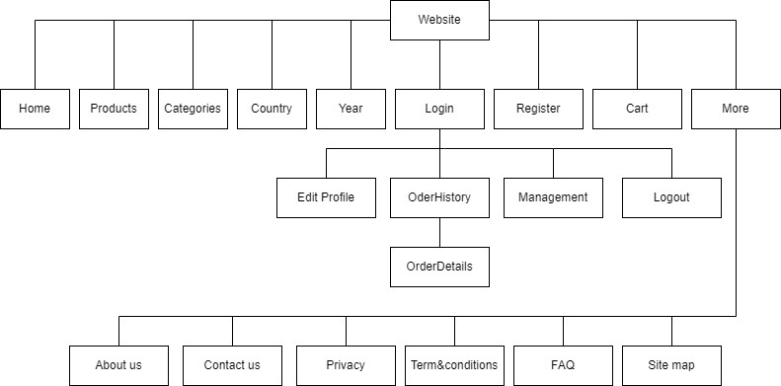

|  |
| --- |
| **Algorithm** |

1. **Admin**

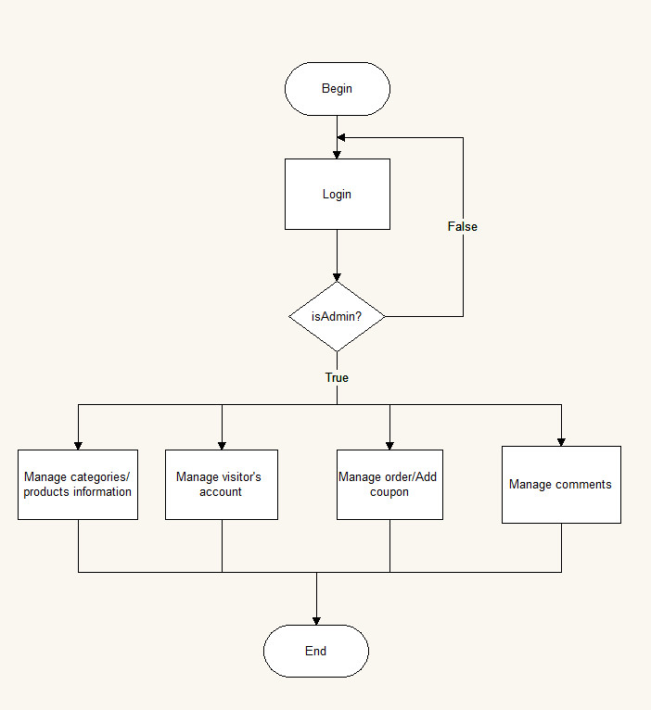

1. **User**

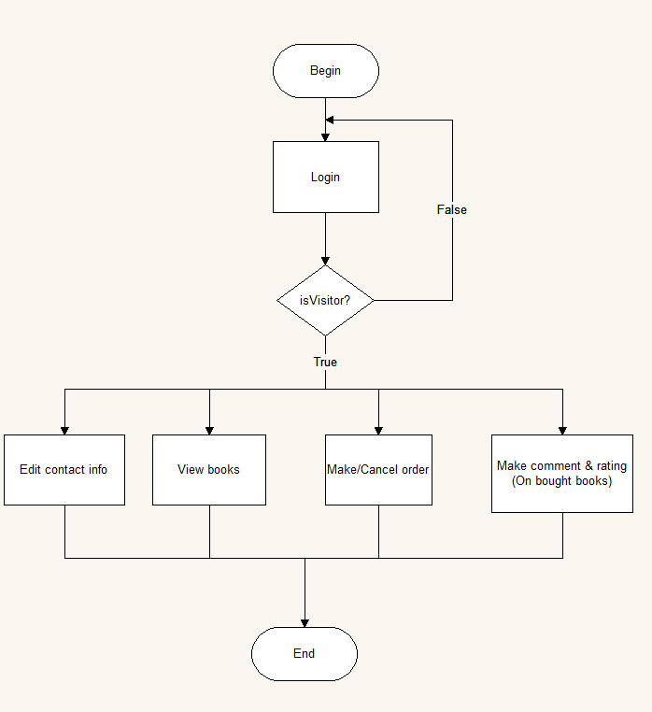

**Review 03**

|  |
| --- |
| **Screen shots** |

1. **Homepage:**
2. **Shop’s banner**



1. **Categories**

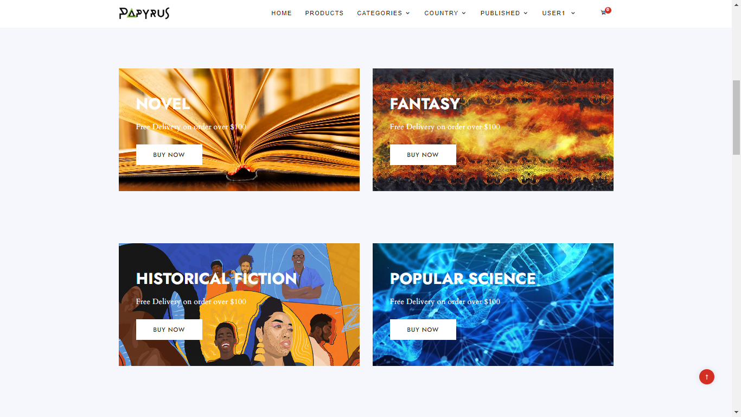

1. **Top Discount, Top Rating, Best seller sliders**

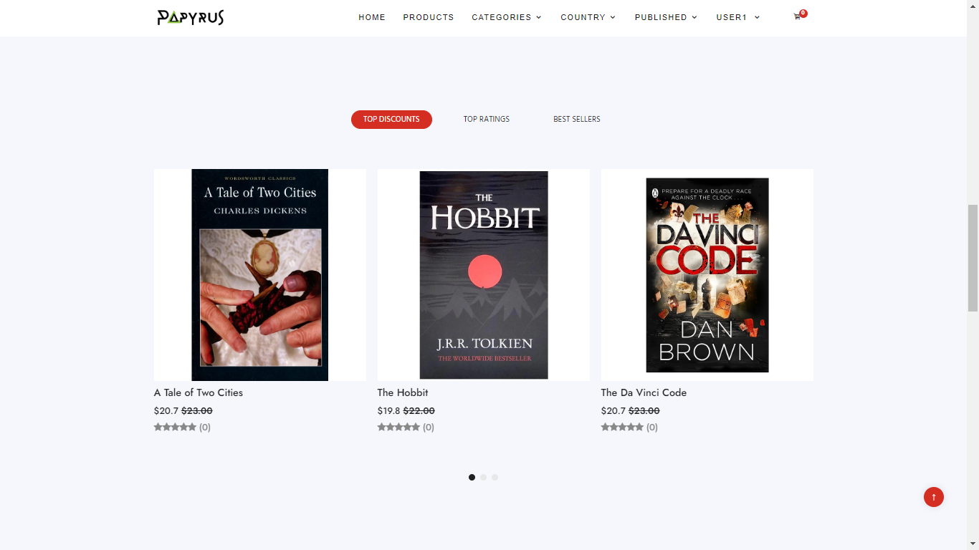

1. **New books**

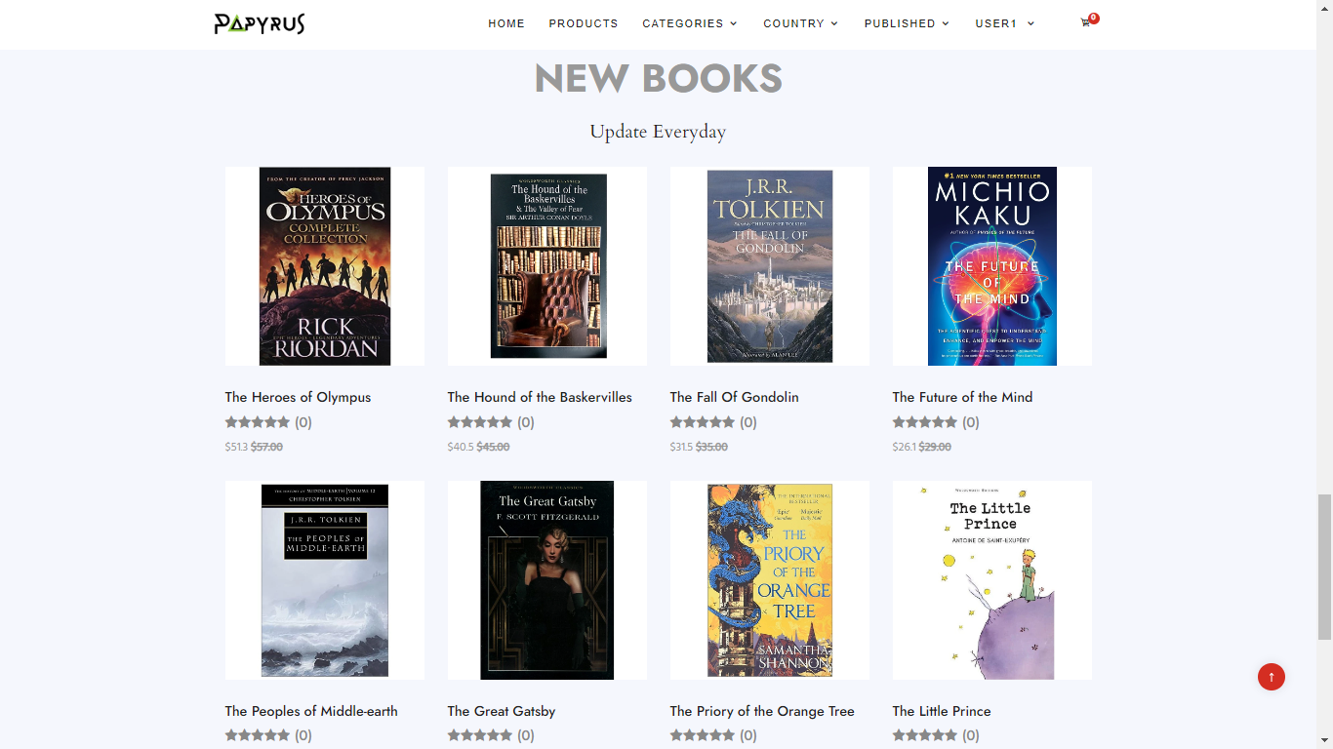

**Description** : The home page gives an overview of books and categories displayed on the website including: a slideshow of promotions, top selling, newest books and other information about the company, this page is the start page of the website.

**From** : Home page

**To** : Products page, Categories page, Language page, Published page, User page, Login page, Register page, Cart page and other information pages including: About us, Contact us, Privacy Policy, Terms & conditions, FAQ, Site map.

1. **Products page, Product details page:**
2. 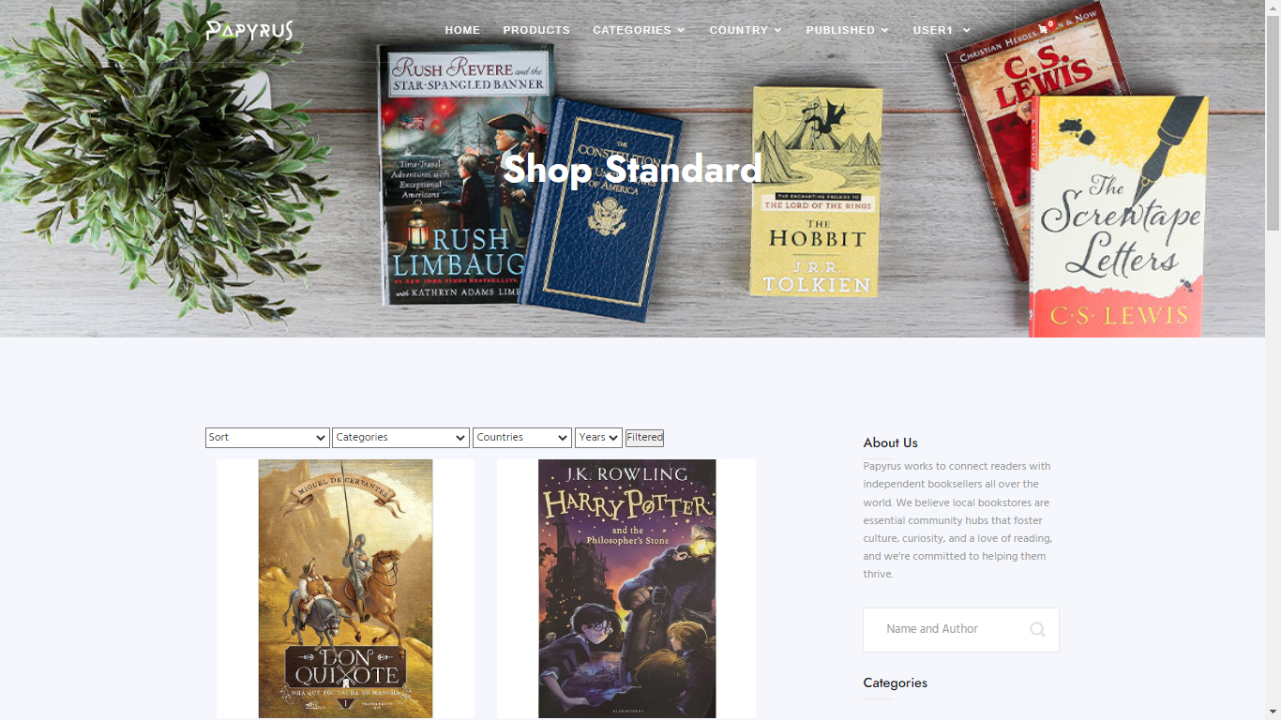**Products Page:**

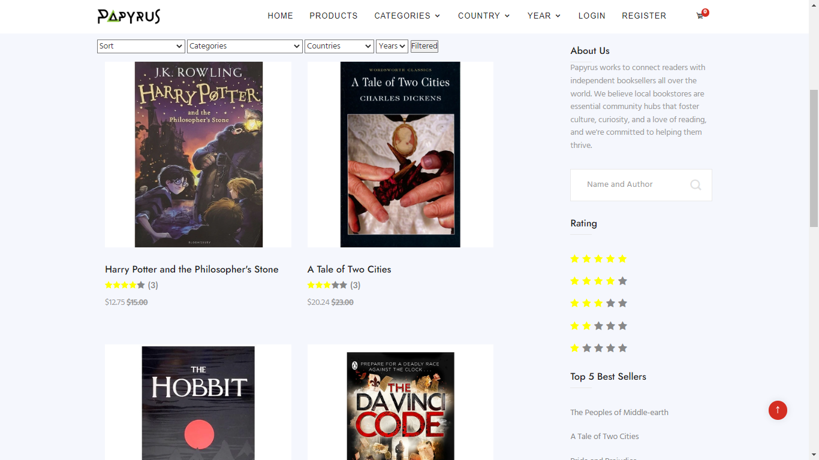

1. **Product details page**

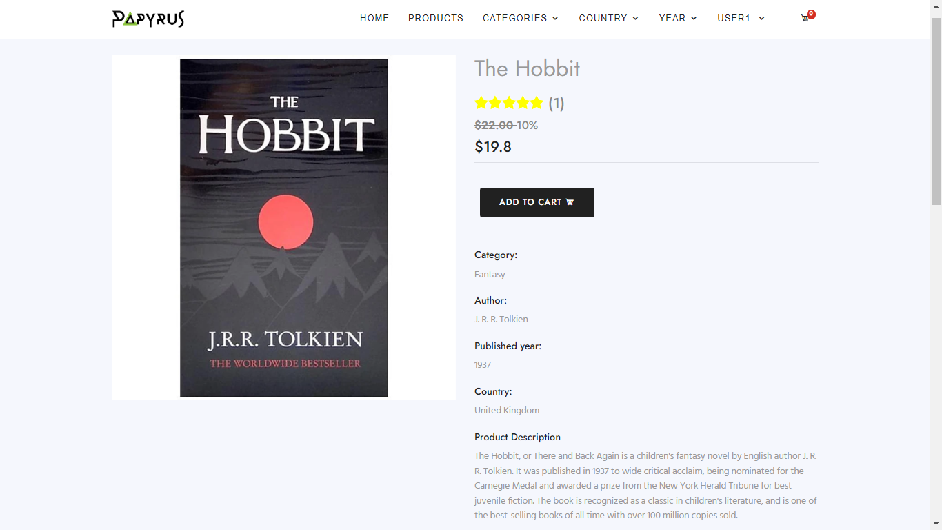

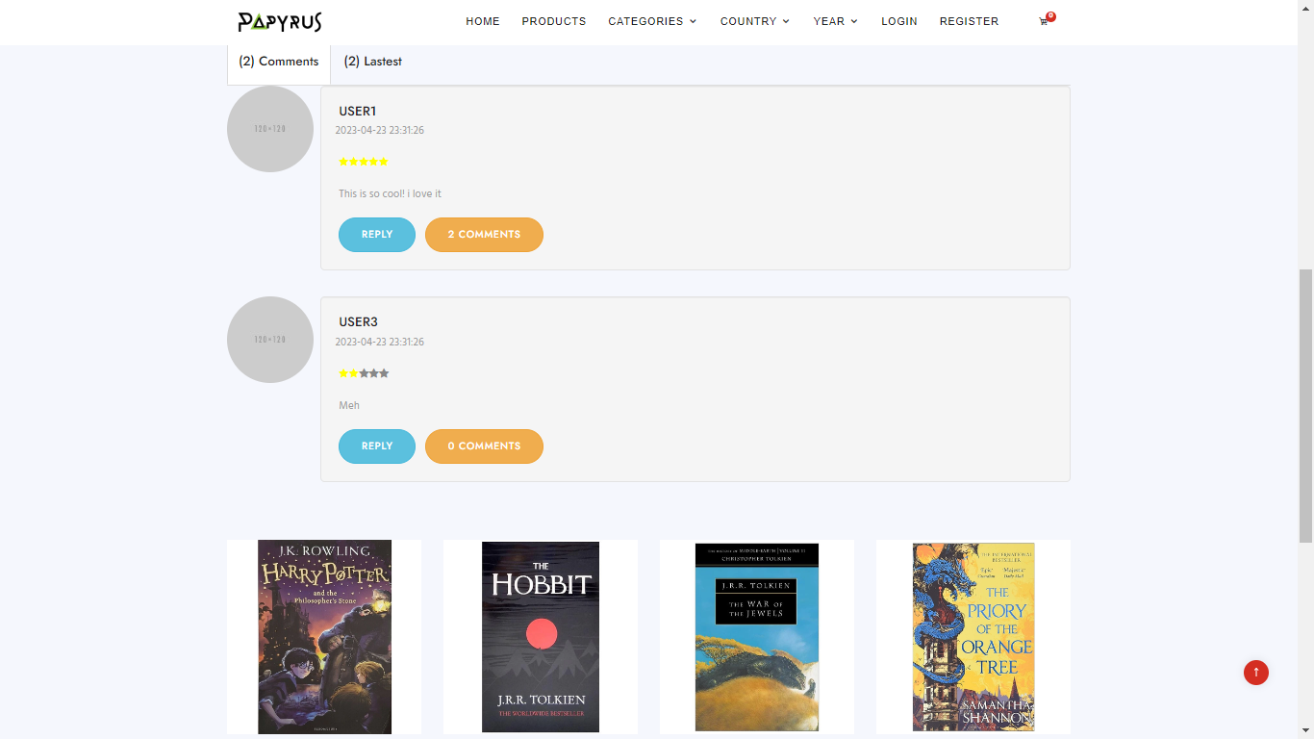

**Description** : this page contains various products with their information sorted by date, price, or published year. People can also search products by their names or author and filter them. Products can be added to cart quickly by a click on the button of each pictures. When the customer clicks on the product title, the product's details page will appear for users to read information, feedbacks from other customer who has bought the book before deciding to buy.

**From** : Products page, productDetail page

**To** : Home page, Categories page, Language page, Published page, User page, Login page, Register page, Cart page and other information pages including: About us, Contact us, Privacy Policy, Terms & conditions, FAQ, Site map.

1. **User page**
2. **Edit profile**

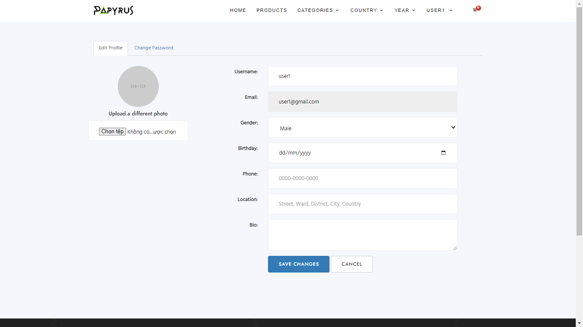

1. **Order history**

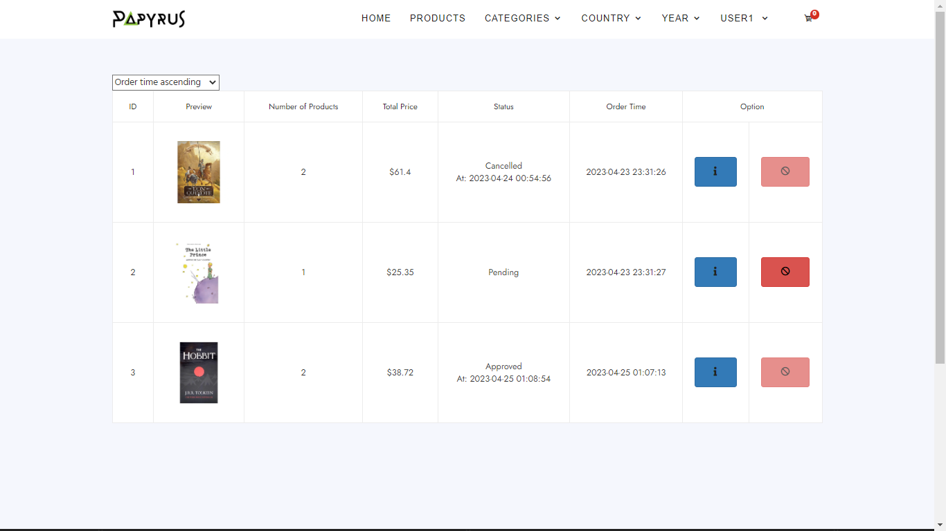

1. **Order Details**

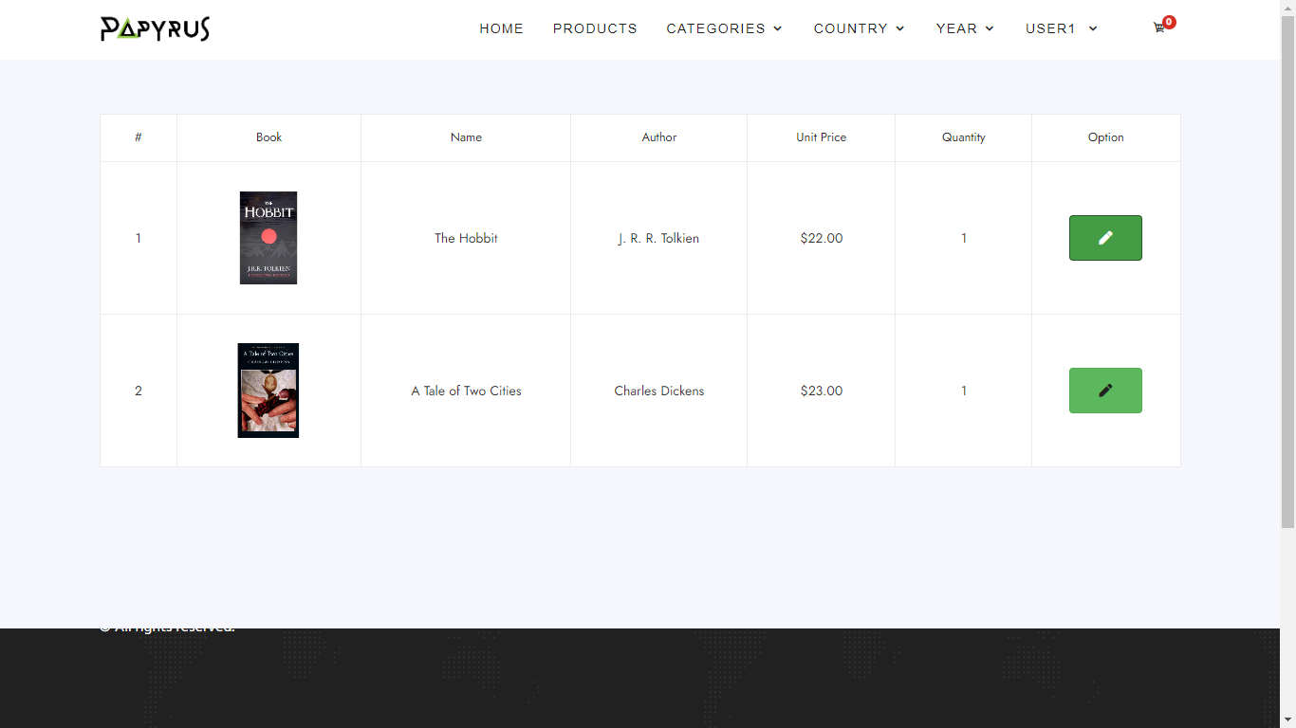

1. **Product Review**

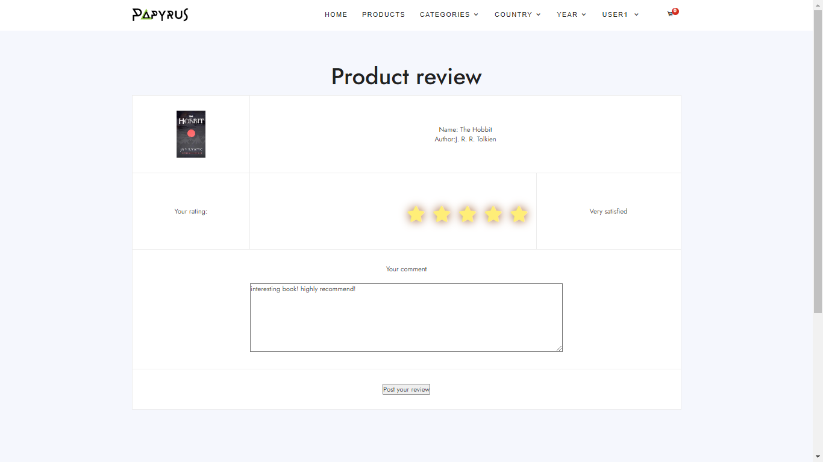

**Description** : this page contains customer’s infomation including: their profile, order history, feedbacks and log out. Customers can edit their profile like: password, name, address, avatar, phone... They can see and cancel their orders if the orders are still in processing status (if status is successed, order can’t be canceled), customers can give their feedbacks (rating, comments) to any products they has bought previously and they will be shown on product detail page.

**From** : User page

**To** : Home page, Products page, Categories page, Language page, Published page, Login page, Register page, Cart page and other information pages including: About us, Contact us, Privacy Policy, Terms & conditions, FAQ, Site map.

1. **Login/Register page**
2. **Login**

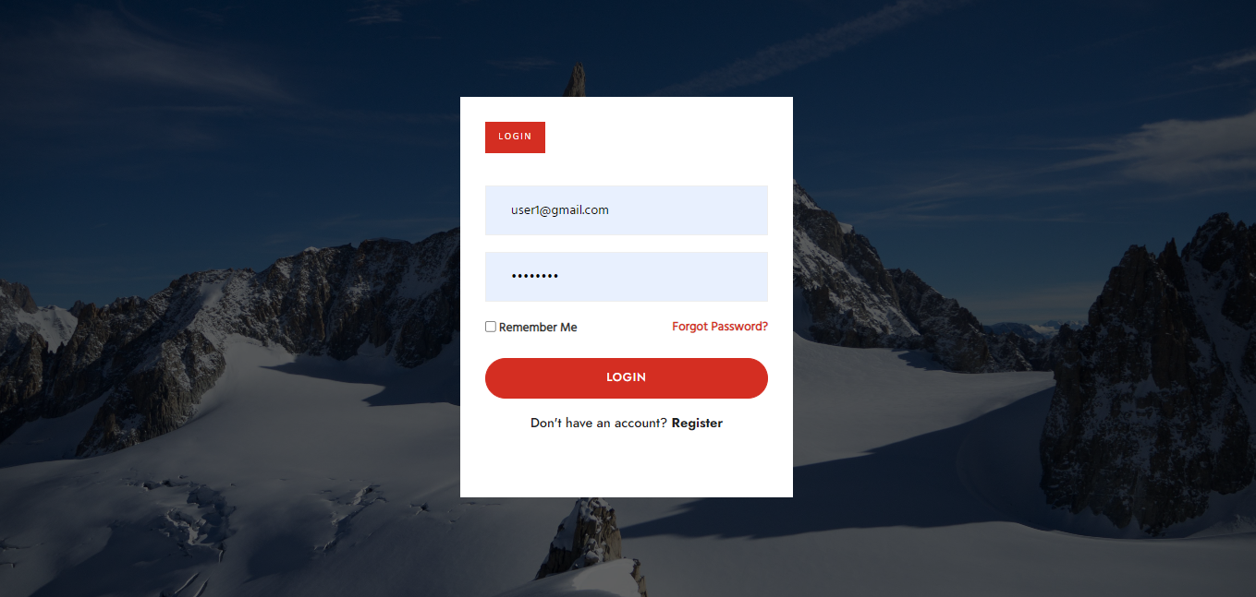

1. **Register**

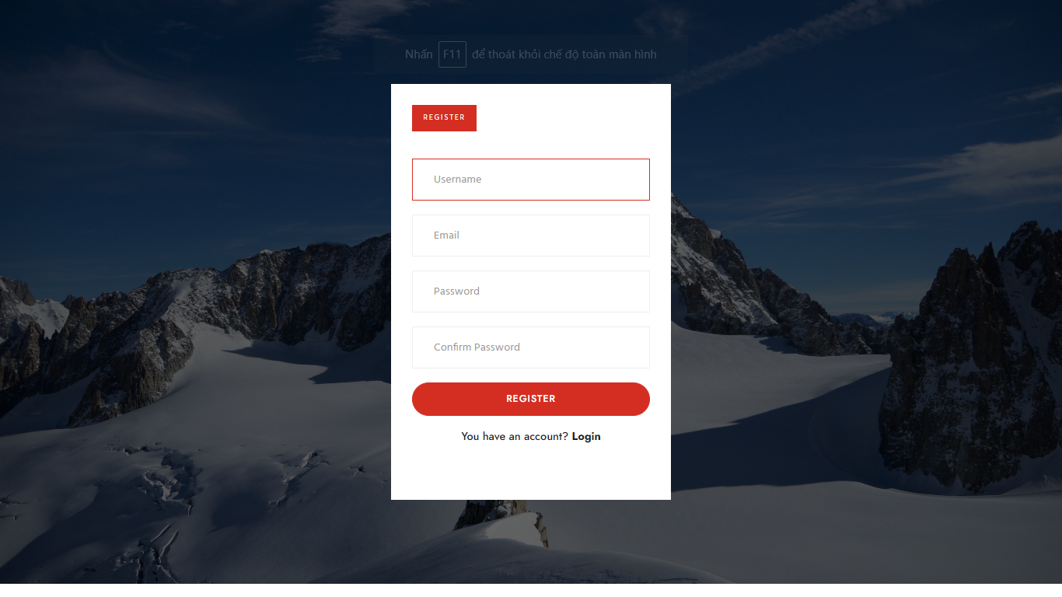

**Description** : These pages allow user to login their account or register one if they don’t have. By login they can buy products and manage their account, order and view all their feedbacks from User page.

**From** : Login/Register page

**To** : Home page, Products page, Categories page, Language page, Published page, User page, Cart page and other information pages including: About us, Contact us, Privacy Policy, Terms & conditions, FAQ, Site map.

1. **Cart page**
2. **Cart**

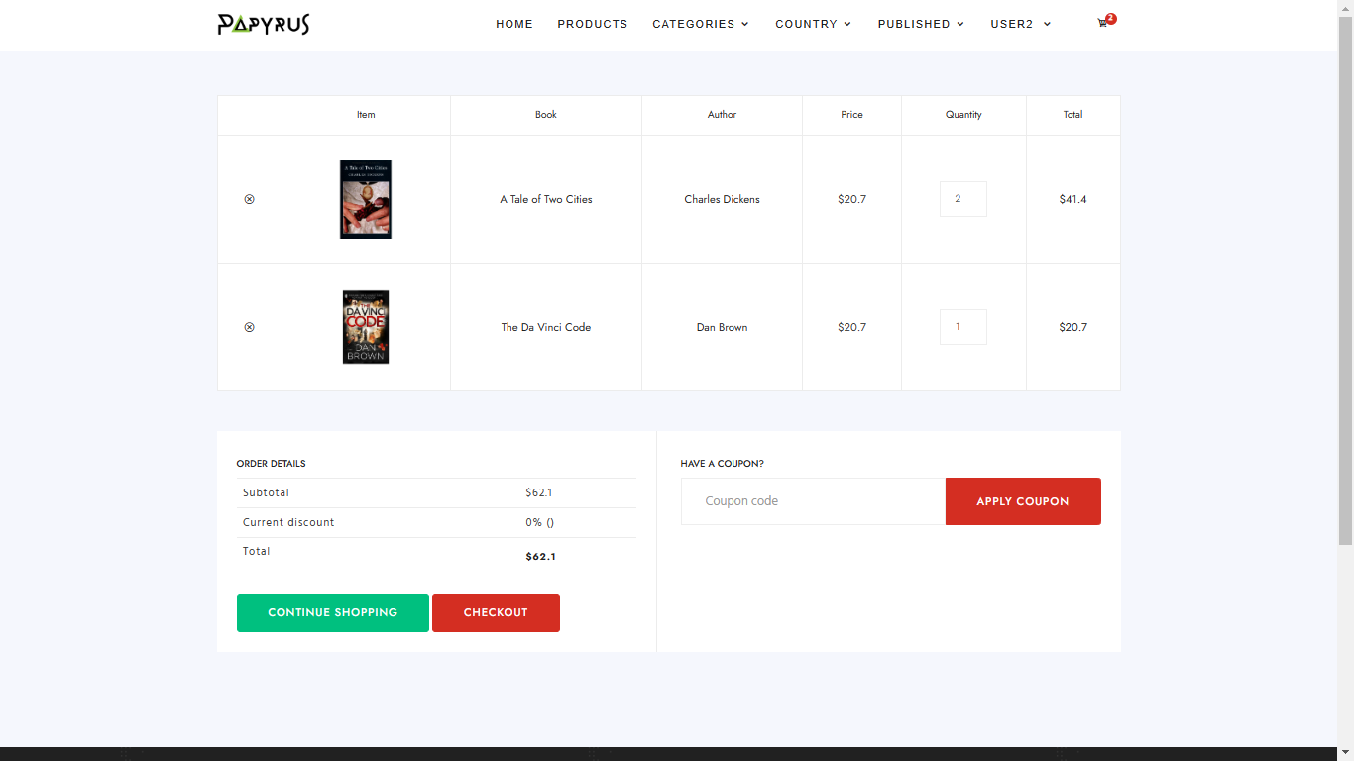

1. **Purchase Confirmation**

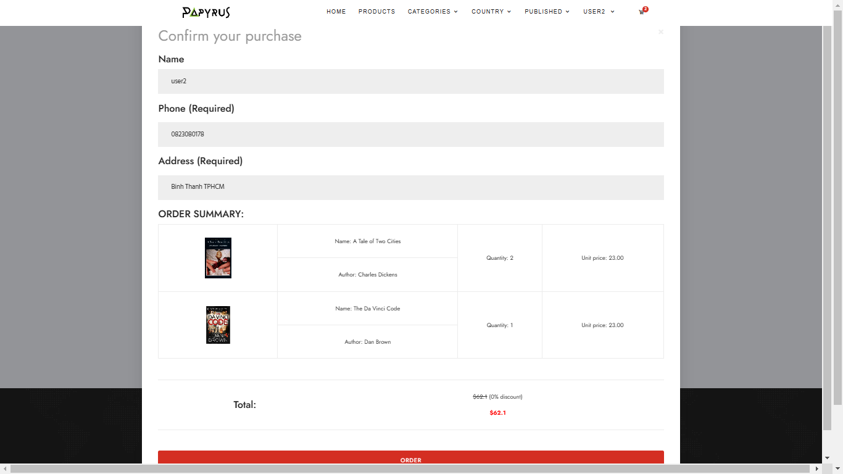

**Description** : this page contains all customer’s order information like: photo, name, price, quantity, coupon, total of all the products that customers “add to cart” from product pages. Coupons can be applied if they haven’t been used and still valid. Customer must confirm their phone numbers and address, they will auto-appear in the box if customer has provided in their profile before otherwise they have to type in by themselves and the information will be auto-saved to the customer’s profile.

**From** : Cart page

**To** : Home page, Products page, Categories page, Language page, Published page, User page, Login page, Register page, and other information pages including: About us, Contact us, Privacy Policy, Terms & conditions, FAQ, Site map.

1. **About Us page**

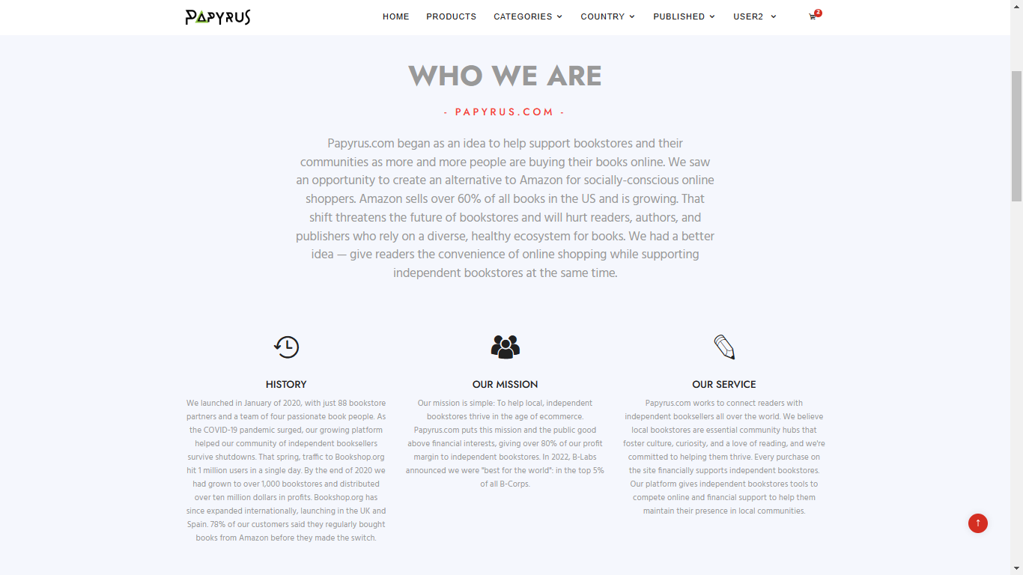

**Description** : this page contains all information about the founder of website including: history, mission, service.

**From** : About Us page

**To** : Home page, Products page, Categories page, Language page, Published page, User page, Login page, Register page, Cart page and other information pages including: Contact us, Privacy Policy, Terms & conditions, FAQ, Site map.

1. **Contact Us page**

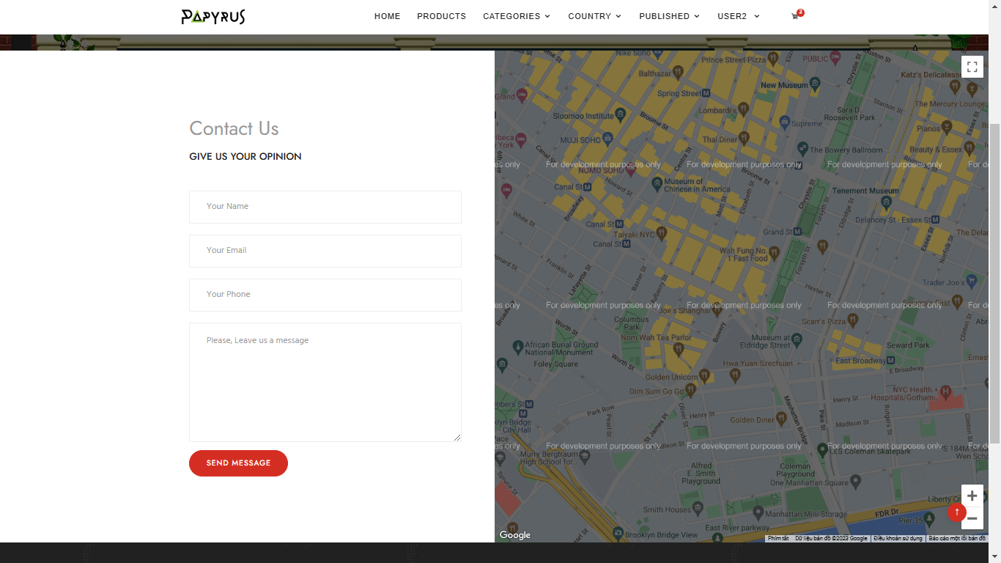

**Description** : customer can send their message to us through this site.

**From** : Contact Us page

**To** : Home page, Products page, Categories page, Language page, Published page, User page, Login page, Register page, Cart page and other information pages including: About us, Privacy Policy, Terms & conditions, FAQ, Site map.

1. **Privacy Policy page**

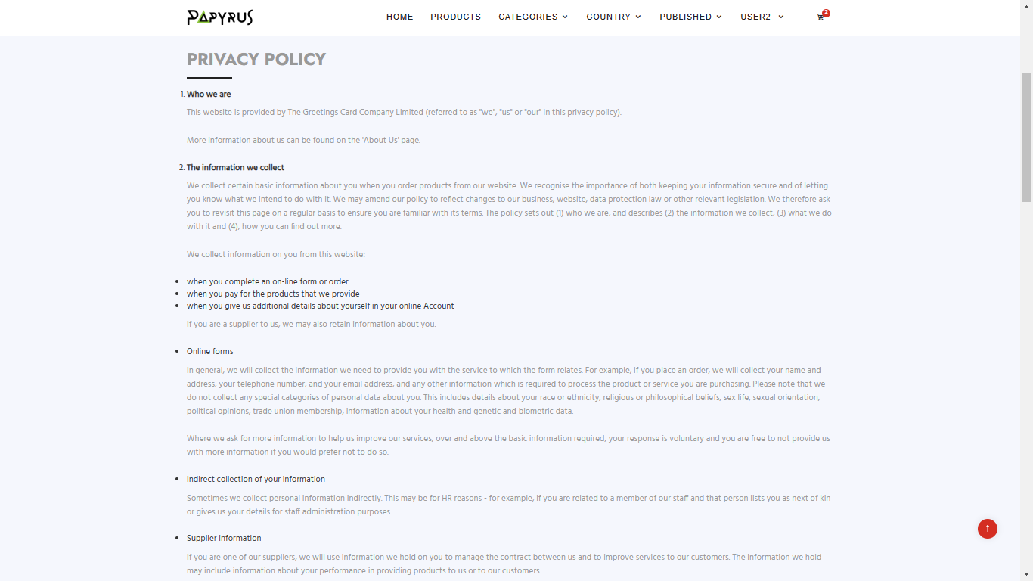

**Description** : customer can consult our policy through this site.

**From** : Privacy Policy page

**To** : Home page, Products page, Categories page, Language page, Published page, User page, Login page, Register page, Cart page and other information pages including: About us, Contact Policy, Terms & conditions, FAQ, Site map.

1. **Terms & Conditions page**

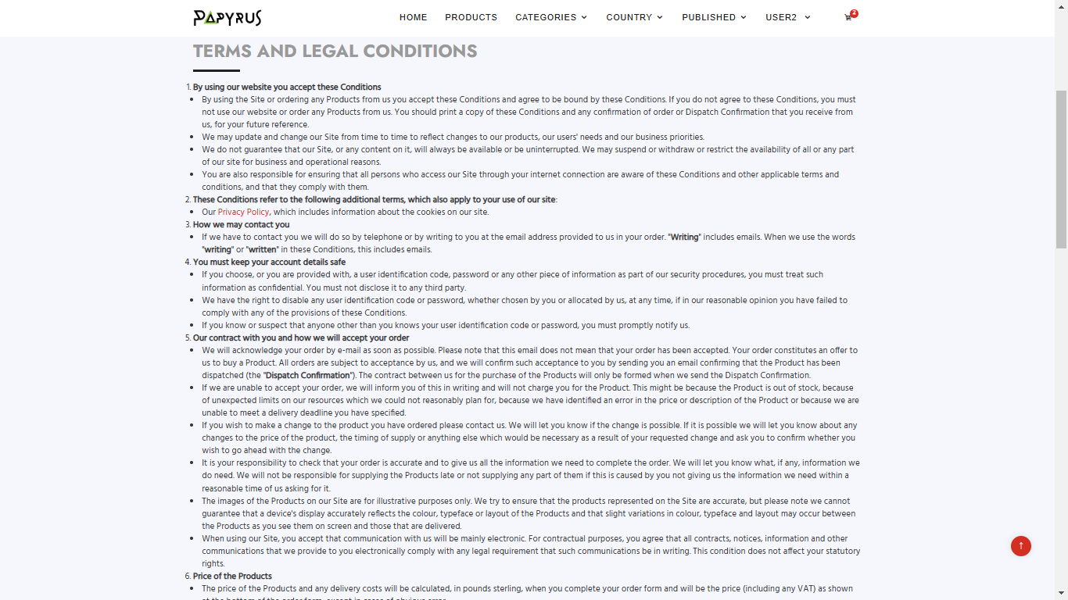

**Description** : customer can consult our Terms and Condition through this site.

**From** : Terms & Conditions page

**To** : Home page, Products page, Categories page, Language page, Published page, User page, Login page, Register page, Cart page and other information pages including: About us, Contact Policy, Privacy Policy, FAQ, Site map.

1. **FAQS page**

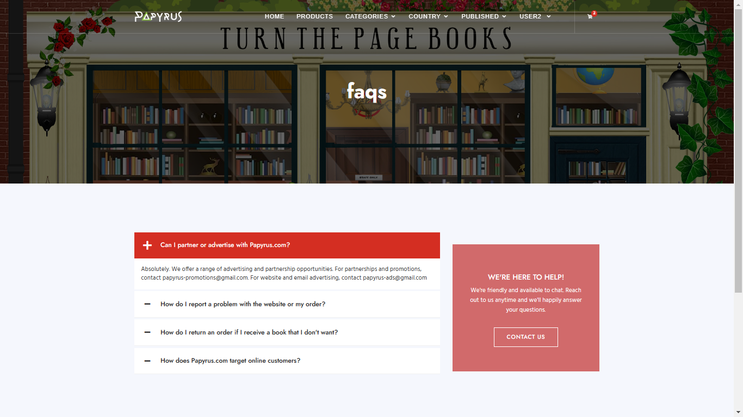

**Description** : customer can find the Frequently Asked Questions and their answers through this site.

**From** : Faqs page

**To** : Home page, Products page, Categories page, Language page, Published page, User page, Login page, Register page, Cart page and other information pages including: About us, Contact Policy, Privacy Policy, Terms & Conditions, Site map.

1. **Site Map page**

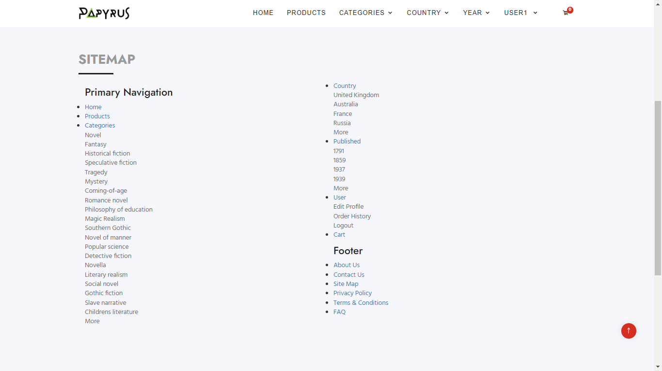

**Description** : customer can find our Site Map through this site.

**From** : Site Map page

**To** : Home page, Products page, Categories page, Language page, Published page, User page, Login page, Register page, Cart page and other information pages including: About us, Contact Policy, Privacy Policy, Terms & Conditions, FAQS.

1. **Admin**
2. **URL:**



1. **User table controller**

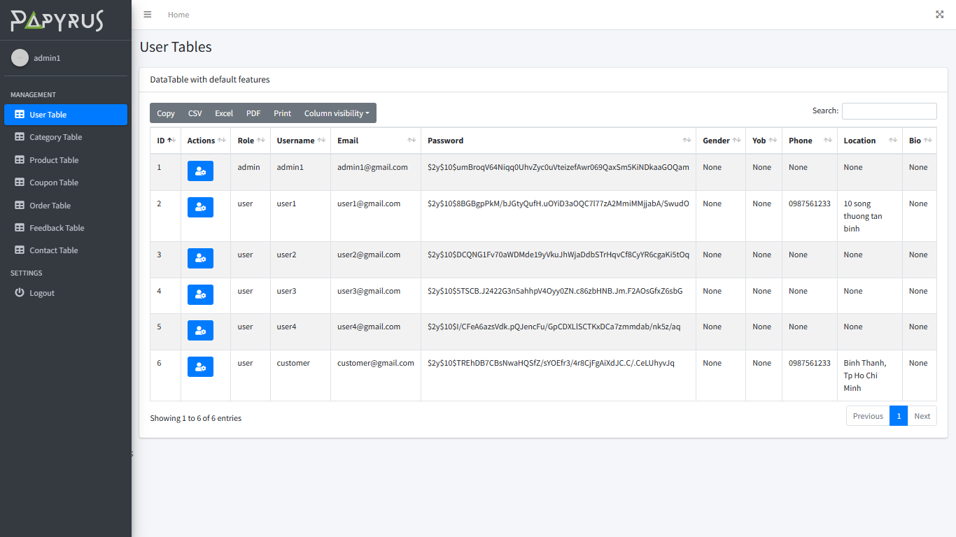

1. **Category Table Controller**

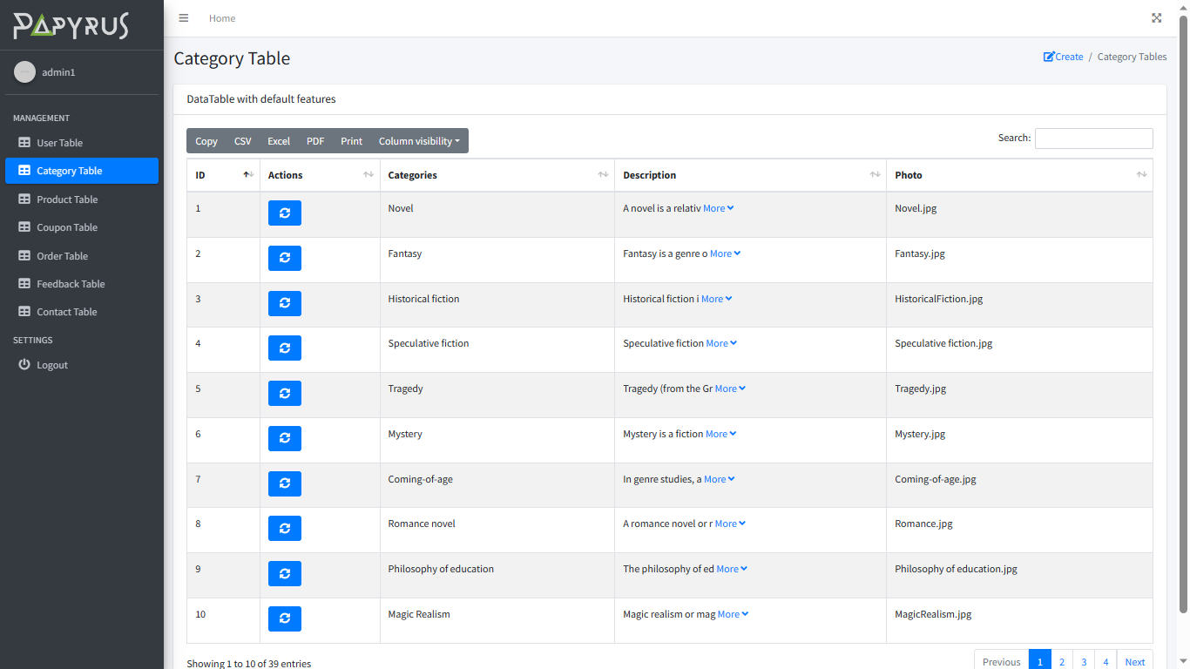

1. **Product Table Controller**

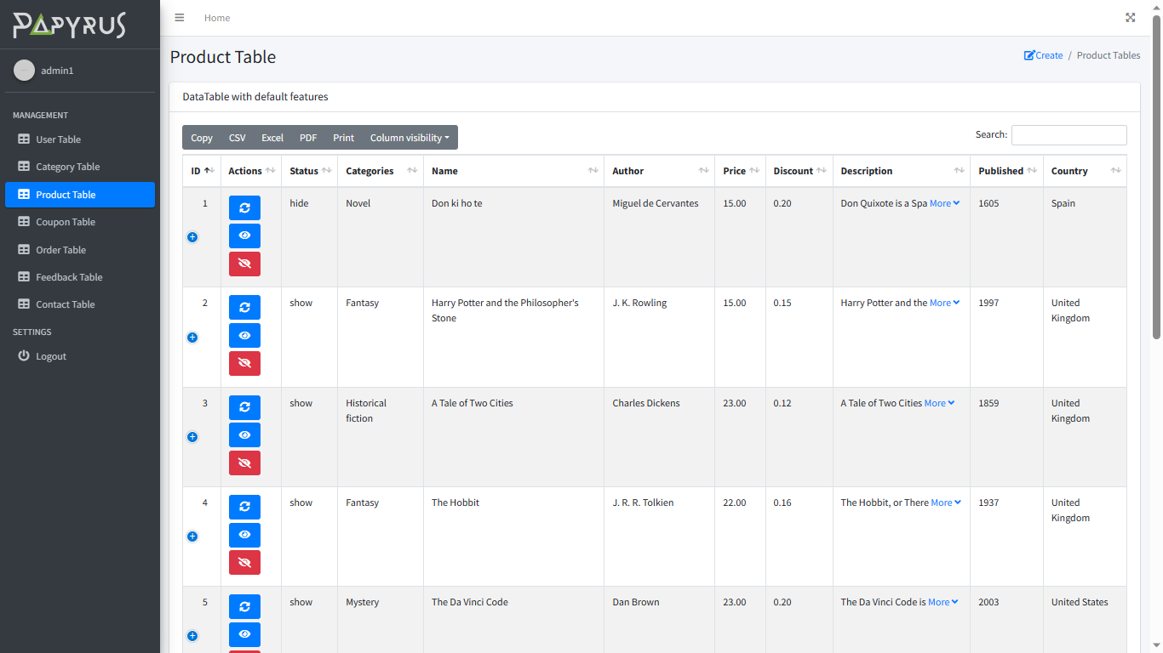

1. **Coupon Table Controller**

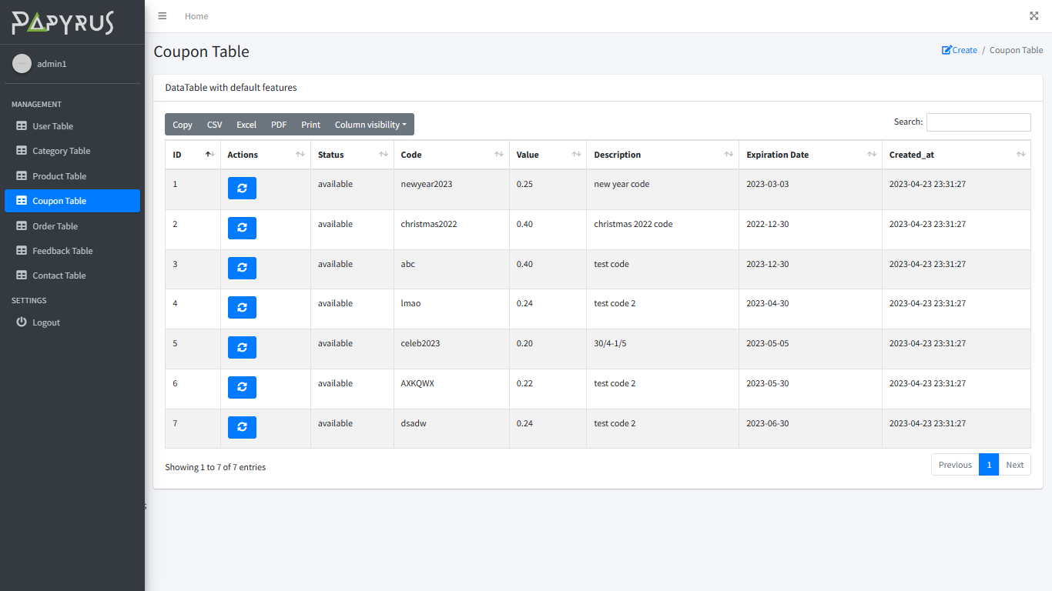

1. **Order Table Controller**

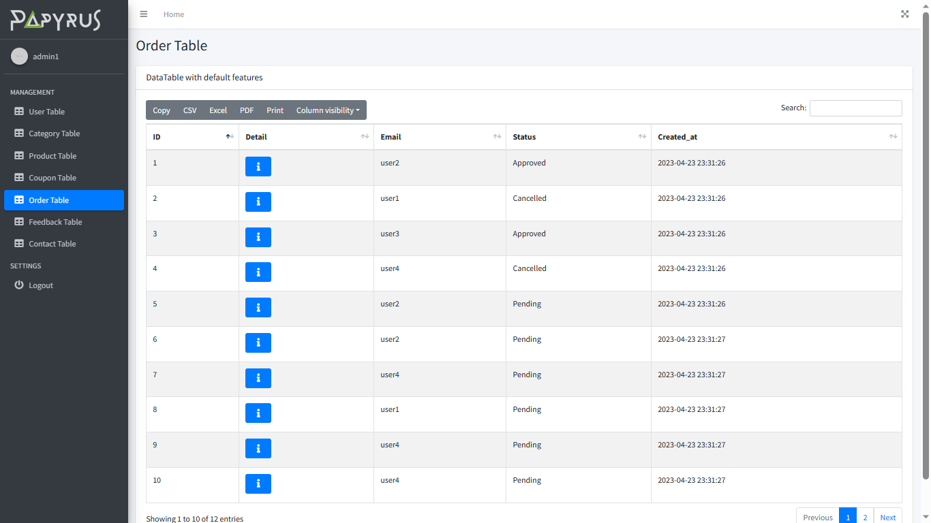

1. **Feedback Table Controller**

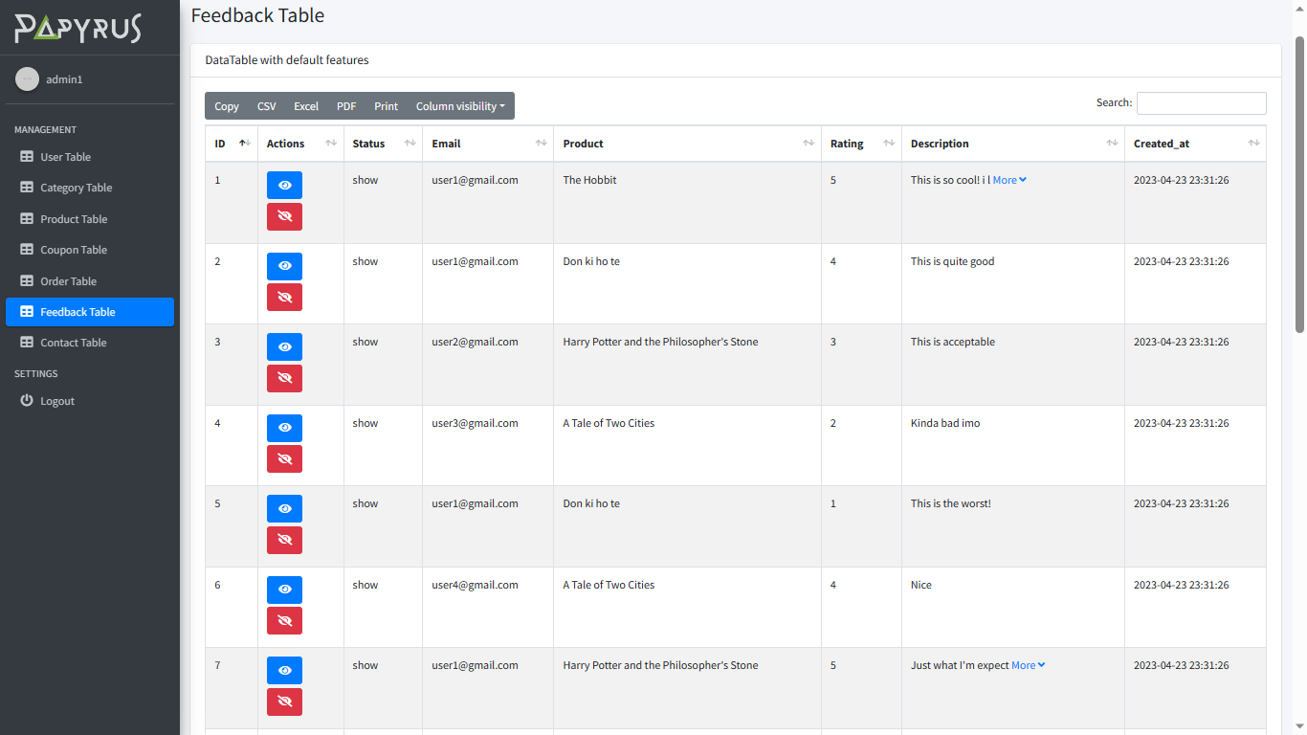

1. **Contact Table Controller**

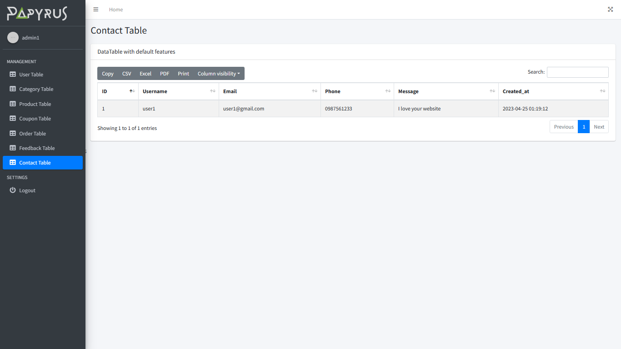

**Description** : For admin account, there will be an URL in User control, this page contains all function like: view, edit, add, delete for admin to control database tables.

**From** : Admin page

**To** : Home page.

|  |
| --- |
| **Testing document** |

|  |  |  |
| --- | --- | --- |
| **Sr.No** | **Features Tested** | **Remarks** |
| 1 |  |  |
| 2 |  |  |
| 3 |  |  |
| 4 |  |  |
| 5 |  |  |
| 6 |  |  |
| 7 |  |  |
| 8 |  |  |
| 9 |  |  |
| 10 |  |  |
| 11 |  |  |
| 12 |  |  |
| 13 |  |  |
| 14 |  |  |
| 15 |  |  |

|  |
| --- |
| **Final checklist** |

|  |  |  |
| --- | --- | --- |
| **Sr.No** | **Aspected Tested** | **Suggestion/**  **Remarks** |
| 1 | Are all the users able to view the images and links? |  |
| 2 | Have all the views, modules and controllers been properly integrated and is the site function as a single page application? |  |
| 3 | Are the GUI content devoid of spelling mistakes? |  |
| 4 | Is the application user-friendly? |  |
| 5 | Is the Website launching correctly in all popular browsers? |  |
| 6 | Are all the forms validated with proper criteria? |  |
| 7 | Do all text links lead to the appropriate website? |  |
| 8 | Do all image links lead to the appropriate website? |  |
| 9 | Are all the images and links clearly visible on the page? |  |
| 10 | Does the Web page work properly in all the tested browsers? |  |
| 11 | Does the Web page take too long to be loaded fully? |  |
| 12 | Is the navigation sequences correct through all the Web pages on the site? |  |
| 13 | Is the JavaScript code working as expected in all click events? |  |
|  |  |  |
|  |  |  |

|  |  |  |  |  |  |  |  |  |
| --- | --- | --- | --- | --- | --- | --- | --- | --- |
| **No** | **Member** | **Contents** | | **Table Name** | **Activity Plan** | **Date of Preparation of Activity Plan** | | |
| **Planed Start Date** | **Actual Start Date** | **Actual Days** | **Status** |
| 1 | **Nguyễn Ngọc Bảo Duy** | Admin | *Product Management* | Products, Categories | 21/03/2023 | 26/03/2023 | 6 | OK |
| 2 | 27/03/2023 | 02/04/2023 | 7 | OK |
| 3 | User | *View Product* | 03/04/2023 | 09/04/2023 | 7 | OK |
| 4 | 10/04/2023 | 17/04/2023 | 7 | OK |
|  |  |  |  |  |  |  |  |  |
| 1 | **Bùi Nguyễn Hải Trí** | Admin | *Customer,Rating, FB Management* | Users, Feedbacks | 21/03/2023 | 26/03/2023 | 6 | OK |
| 2 | 27/03/2023 | 02/04/2023 | 7 | OK |
| 3 | User | *Register, Send Comment/Rating* | 03/04/2023 | 09/04/2023 | 7 | OK |
| 4 | *Personal Account, FB, CM Management* | 10/04/2023 | 17/04/2023 | 7 | OK |
|  |  |  |  |  |  |  |  |  |
| 1 | **Trịnh Hoàng Phước Sang** | Admin | *Order Management* | Orders, OrderDetails, Coupons | 21/03/2023 | 26/03/2023 | 6 | OK |
| 2 | 27/03/2023 | 02/04/2023 | 7 | OK |
| 3 | User | *Add Order* | 03/04/2023 | 09/04/2023 | 7 | OK |
| 4 | *Personal Order Management* | 10/04/2023 | 17/04/2023 | 7 | OK |
|  |  |  |  |  |  |  |  |  |
| 1 | **Lê Mai Minh Thiện** | Admin | *Mail-Box Management* | MailBox | 21/03/2023 | 26/03/2023 | 6 | N/A |
| 2 | 27/03/2023 | 02/04/2023 | 7 | N/A |
| 3 | User | *Send e-mail* | 03/04/2023 | 09/04/2023 | 7 | N/A |
| 4 | *Personal e-mail Management* | 10/04/2023 | 17/04/2023 | 7 | N/A |